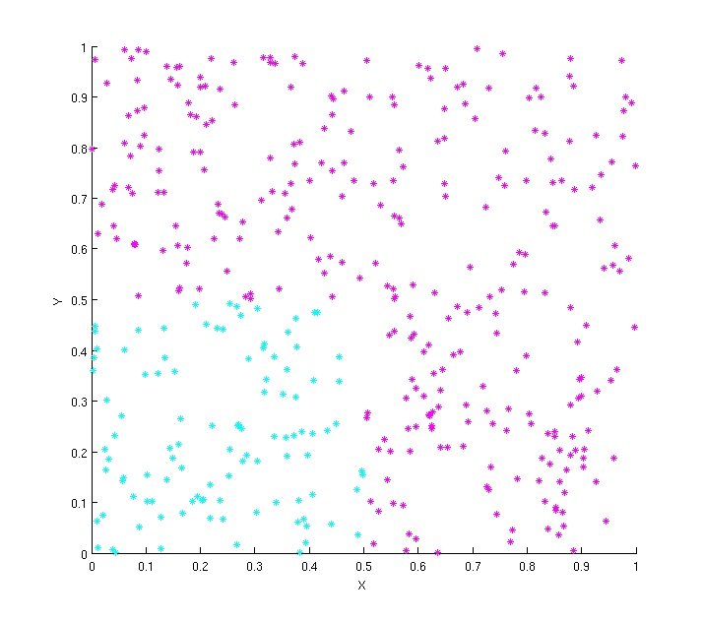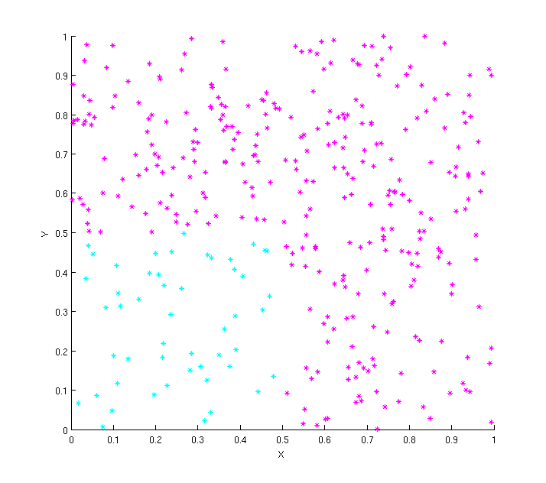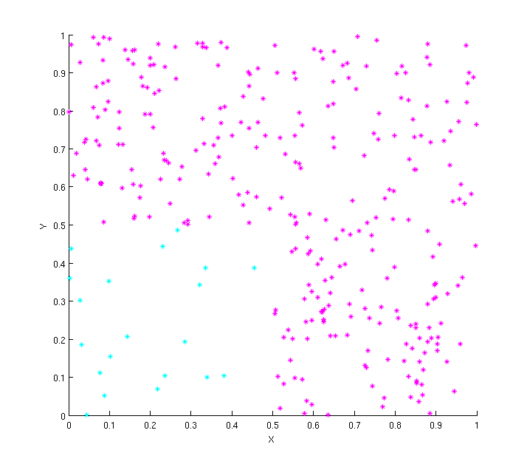

 |  | Set 1(1) | Set 1(0) | Set 2(1) | Set 2(0) | Set 3(1) | Set 3(0)
kNN  no weighting | k=1 | .986 | .962 | .995 | .970 | .997 | .947
kNN  no weighting | k=5 | .982 | .946 | .992 | .947 | .993 | .889
kNN  no weighting | k=10 | .985 | .957 | .990 | .936 | .987 | .750
kNN  no weighting | k=20 | .975 | .957 | .986 | .901 | .985 | .701
kNN  1/d weighting | k=5 | .993 | .981 | .995 | .969 | .993 | .889
kNN  1/d weighting | k=10 | .995 | .986 | .995 | .969 | .992 | .857
kNN  1/d weighting | k=20 | .997 | .990 | .994 | .958 | .988 | .788
Ripper |  | .995 | .986 | .994 | .958 | .997 | .947
Naïve Bayes |  | .962 | .877 | .970 | .765 | .989 | .571

- In general, for no weighting as k increases, the performance decreases. This is because as k increases we are more likely to capture some samples of the class we aren’t looking for. A large enough k turns this classification method into a majority vote and since class 1 is larger than class 0, as k increases our classification rate will go down. This is more true for class 0 as we see the worst case is .701 for k=20 for dataset 3.
- From dataset 1 to dataset 3, there are fewer samples in class 0. If k is too large, there will never be enough samples to make it the majority class, as we see in dataset 3(20 samples, need 11 for majority in classification). Classification for class 1 remains roughly the same although it goes up slightly as the number of class 0 samples goes down. The classification for class 0 goes down precipitously as the number of samples in that class decrease.
- We see an increase in performance if we use inverse distance weighting. There is the same general trend of decrease performance as we imbalance classes and increase k, but the impact is lessened as we use weighting. Because we use weighting we discount nearest neighbors that are farther away lessening the likelihood that other class samples will impact the current classification.
- We see that Ripper does very well for class 0 and class 1 and all datasets because it handles imbalanced classes easily as well as easily delineated problem spaces.
- Of all the classifiers, Naïve Bayes does the worst. For the first dataset, when the classes are evenly distributed spatially, it does the best, although it does worse on class 0 since its prior is less than the prior of class 1. As those prior become imbalanced, Naïve Bayes improves the more likely class at the expense of the rarer class.
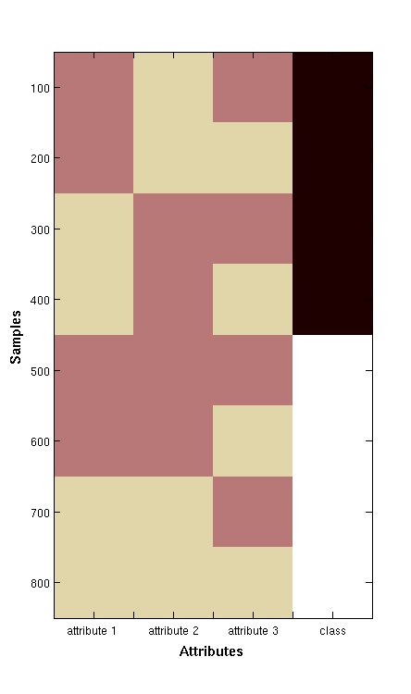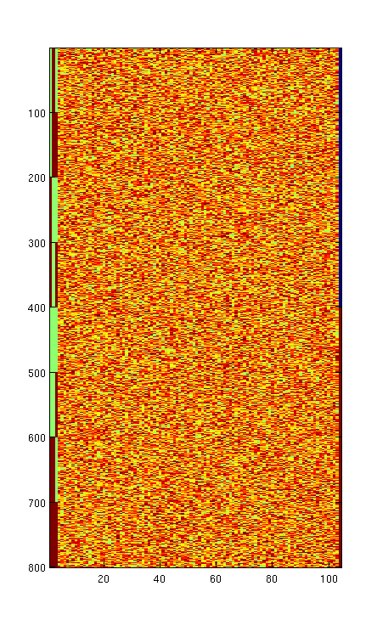

 |  | Set 1(1) | Set 1(-1) | Set 2(1) | Set 2(-1)
kNN | k=1 | 1.00 | 1.00 | .771 | .764
kNN | k=5 | 1.00 | 1.00 | .844 | .841
J48 |  | 1.00 | 1.00 | 1.00 | 1.00
Naïve Bayes |  | 0.482 | .448 | .520 | .512
Ripper |  | 1.00 | 1.00 | .477 | .491

- For dataset 1, the worst performer is Naïve Bayes. Since the class attributes are evenly distributed, it is basically making a random guess as to which class a test sample belongs to. All the other algorithms are able to discover some deeper relations between attribute and class.
- Ripper shows the biggest drop from dataset 1 to dataset 2. This is because with the irrelevant attributes added it has a harder time finding the important signal. It is highly likely one of the random attributes might perform better than 50% and be selected by Ripper over a relevant attribute.
- The decision tree did the same on both datasets because it is inherently good at handling noisy data. It was still able to find, despite the extra 100 attributes, that the important attributes were the first 3.

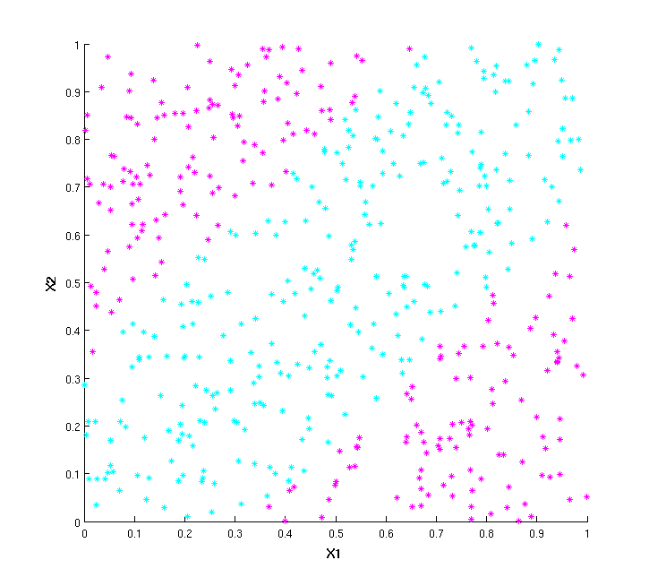

 |  | Set 1(0) | Set 1(1) | Set 2(0) | Set 2(1) | Set 3(0) | Set 3(1)
kNN | k=1 | .969 | .962 | .530 | .580 | .461 | .541
kNN | k=10 | .967 | .956 | .573 | .436 | .559 | .449
J48 |  | .913 | .878 | .561 | .582 | .427 | .590
Naïve Bayes |  | .669 | .269 | .464 | .744 | .440 | .698

- kNN does the best on the dataset 1 since it is the best at handling arbitrarily shaped boundaries. J48 does nearly as well but the decision tree is fairly complex and the space is decomposed into a series of smaller decision rectangles. Naïve Bayes is again basically guessing because of the nearly even split between classes.
- As the datasets add more noise, we see the performance degrade for both kNN and decision trees. Contrary to the previous test, decision trees in this case degrade in the presence of noise because the original dataset is not rectilinearly separable. kNN degrades because kNN does not handle noisy datasets well.
- Naïve Bayes basically guesses for all the datasets with a little more weight given to the probable class.

 |  | Sick | Negative
kNN | k=5 | .629 | .981
Naïve Bayes |  | .562 | .960
Ripper |  | .991 | .860

- There were 29 attributes, 7 continuous(6 real, 1 integer) and 22 discrete(mostly T/F). Also, there were 3541 negative cases but only 231 sick cases. That data description plays specifically to Ripper’s strengths. As we can see, it did the best in finding the sick cases and reasonably well in finding the negative cases. Interestingly, Ripper used the referral source in one of its rules which is odd since you would think the referral source would be irrelevant to the diagnosis.
- kNN did pretty good in finding the negative cases, which were the larger class, but much worse in finding the smaller class. Presumably kNN would have had problems with the missing data. Also, kNN might have had problems with attribute mixtures.
- Naïve Bayes did reasonably well in finding the negative cases, again because of the imbalanced classes making one class more probable than another. Also, there are some correlated attributes which degrade the performance of Naïve Bayes(sex:pregnant, sick: on thyroxine, various measurements, etc).
- If one were to just make the diagnosis of negative for all cases, the F-score on negative would be .969, which would beat Ripper and Naïve Bayes. However, the F-score for sick cases would be 0.00, which is much worse.

